Database Project: The Logical Relational Model

Part 1: Introduction
Project Overview
The purpose of this project is to design and implement a database that organizes and manages the key information identified in the requirements phase. The database will store entities, their attributes, and the relationships between them, ensuring that data can be accessed, updated, and maintained efficiently. The primary function of the system is to provide a structured data model that supports accurate storage and retrieval of information for the intended use cases.
Scope
The scope of this project is limited to modeling the core entities, attributes, and relationships required to represent the data needs outlined in the requirements document. The database will not include features outside of these identified requirements, such as advanced analytics, user interface design, or external system integration. The focus is on delivering a complete ER model that captures all necessary data elements, enforces integrity through constraints, and provides a clear blueprint for future implementation.
Glossary
- Entity – An object or concept that stores data in the database.
- Attribute – A property or characteristic of an entity.
- Relationship – A connection between two or more entities.
- Cardinality – The numerical mapping that defines the relationships between entities
- Primary Key (PK) – A unique identifier for each record in an entity.
- ER Model – A diagrammatic representation of entities, attributes, and relationships.
- Supertype - generic entity that contains the common attributes shared by multiple related entities.
- Subtype - specialized entity that inherits the attributes but also has its own unique attributes.
- Transaction - A single logical unit of work that consists of one or more operations
- Foreign Key (FK) - Database is a field (or a set of fields) in one table that uniquely identifies a row in another table.
- Candidate Key - a database is a minimal set of attributes that can uniquely identify a row in a relation.

Part 2: Create a Relational Schema Diagram
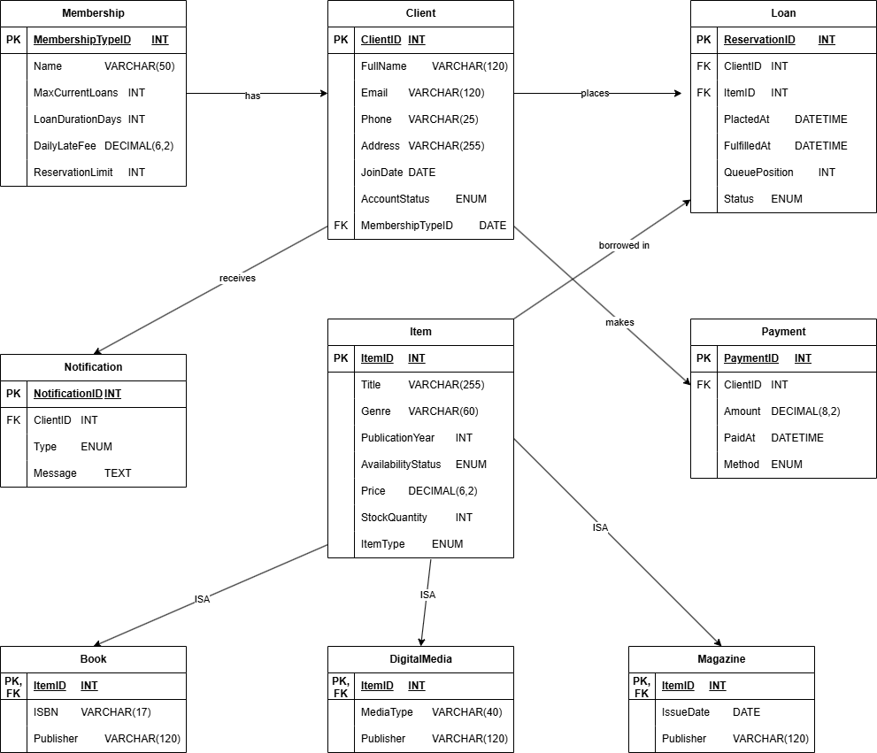

Part 3: Relational Schema Mapping
Identify Relations:
Membership(MembershipTypeID, Name, MaxCurrentLoans, LoanDurationDays, DailyLateFee, ReservationLimit)
Client(ClientID, FullName, Email, Phone, Address, JoinDate, AccountStatus, MembershipTypeID)
Item(ItemID, Title, Genre, PublicationYear, AvailabilityStatus, Price, StockQuantity, ItemType)
Book(ItemID, ISBN, Publisher)
DigitalMedia(ItemID, MediaType, Publisher)
Magazine(ItemID, IssueDate, Publisher)
Loan(ReservationID, ClientID, ItemID, PlacedAt, FulfilledAt, QueuePosition, Status)
Payment(PaymentID, ClientID, Amount, PaidAt, Method)
Notification(NotificationID, ClientID, Type, Message)
Define Attributes and Domains：
Attribute | Data Type | Domain / Allowed Values
MembershipTypeID | INT | Positive integers
Name | VARCHAR(50) | Text string ≤ 50 chars
MaxCurrentLoans | INT | 0 – 20
LoanDurationDays | INT | 1 – 60
DailyLateFee | DECIMAL(6,2) | ≥ 0.00
ReservationLimit | INT | 0 – 10
ClientID | INT | Positive integers
FullName | VARCHAR(120) | Up to 120 characters
Email | VARCHAR(120) | Valid email format
Phone | VARCHAR(25) | Alphanumeric
Address | VARCHAR(255) | Up to 255 characters
JoinDate | DATE | Valid calendar date
AccountStatus | ENUM | {‘Active’, ‘Suspended’, ‘Closed’}
MembershipTypeID | INT | Positive integers
ItemID | INT | Positive integers
Title | VARCHAR(255) | Up to 255 characters
Genre | VARCHAR(60) | Up to 60 characters
PublicationYear | INT | 1000 – Current Year
AvailabilityStatus | ENUM | {‘Available’, ‘OnLoan’, ‘Lost’, ‘Damaged’}
Price | DECIMAL(6,2) | ≥ 0.00
StockQuantity | INT | ≥ 0
ItemType | ENUM | {‘Book’, ‘DigitalMedia’, ‘Magazine’}
ItemID | INT | FK → Item
ISBN | VARCHAR(17) | Valid ISBN-10 or ISBN-13
Publisher | VARCHAR(120) | Text ≤ 120 chars
ItemID | INT | FK → Item
MediaType | VARCHAR(40) | e.g., ‘DVD’, ‘eBook’, ‘Audio’
Publisher | VARCHAR(120) | Text ≤ 120 chars
ReservationID | INT | Positive integers
ClientID | INT | Positive integers
ItemID | INT | Positive integers
PlacedAt | DATETIME | Valid date and time value
FulfilledAt | DATETIME | Nullable; valid date and time
Status | ENUM | {‘Active’, ‘Cancelled’, ‘Fulfilled’, ‘Expired’}
QueuePosition | INT | ≥ 1
PaymentID | INT | Positive integers
ClientID | INT | FK → Client
Amount | DECIMAL(8,2) | > 0
PaidAt | DATETIME | Valid timestamp
Method | ENUM | {‘Cash’, ‘Card’, ‘Online’}
NotificationID | INT | Positive integers
ClientID | INT | FK → Client
Type | ENUM | {‘DueSoon’, ‘Overdue’, ‘ReservationAvailable’}
Message | TEXT | Up to 2000 characters
Determine Primary Keys：

Relation | Primary Key
Membership | MembershipTypeID
Client | ClientID
Item | ItemID
Book | ItemID
DigitalMedia | ItemID
Magazine | ItemID
Loan | ReservationID
Payment | PaymentID
Notification | NotificationID

Establish Foreign Keys：

Relation | Foreign Key | References
Client | MembershipTypeID | Membership(MembershipTypeID)
Book | ItemID | Item(ItemID)
DigitalMedia | ItemID | Item(ItemID)
Magazine | ItemID | Item(ItemID)
Loan | ClientID | Client(ClientID)
Loan | ItemID | Item(ItemID)
Payment | ClientID | Client(ClientID)
Notification | ClientID | Client(ClientID)

Establish the functional dependencies (FDs):
MembershipTypeID → Name, MaxCurrentLoans, LoanDurationDays, DailyLateFee, ReservationLimit
(Each membership type determines its loan limits and fees.)
ClientID → FullName, Email, Phone, Address, JoinDate, AccountStatus, MembershipTypeID
(Each client’s ID determines their personal and membership information.)
ItemID → Title, Genre, PublicationYear, AvailabilityStatus, Price, StockQuantity, ItemType
(Each item record uniquely defines its own descriptive attributes.)
LoanID → ClientID, ItemID, CheckoutAt, DueAt, ReturnedAt, Status
(Each loan record uniquely links one client and one item with a specific status.)
PaymentID → ClientID, Amount, PaidAt, Method
(Each payment record corresponds to one client transaction.)
NotificationID → ClientID, Type, Message
(Each notification corresponds to one client and a specific alert type.)

Part 4: Schema Documentation With a Data Dictionary
Membership
Attribute Name | Data Type | Description | Constraints
MembershipTypeID | INT | Unique ID for membership type | PK
Name | VARHAR(50) | Membership type (e.g., Regular, Student, Senior) | NOT NULL
MaxCurrentLoans | INT | Maximum active loans allowed | >= 0
LoanDurationDays | INT | Number of days items can be borrowed | >= 1
DailyLateFee | DECIMAL(6,2) | Fee Charged per late day | >= 0
ReservationLimit | INT | Maximum number of active reservations | >= 0

Client
Attribute Name | Data Type | Description | Constraints
ClientID | INT | Unique client identifier | PK
FullName | VARCHAR(120) | Client’s full name | NOT NULL
Email | VARCHAR(12) | Client’s email address | UNIQUE, NOT NULL
Phone | VARCHAR(25) | Client’s contact number
Address | VARCHAR(255) | Client’s physical address
JoinDate | DATE | Date client joined | DEFAULT CURRENT_DATE
AccountStatus | ENUM(‘Active’, ‘Suspended’, ‘Closed’) | Current account state | DEFAULT ‘Active’
MembershipTypeID | INT | Reference to MembershipType | PK → MembershipType

Item (Supertype)
Attribute Name | Data Type | Description | Constraints
ItemID | INT | Unique ID for each item | PK
Title | VARCHAR(255) | Title of the item | NOT NULL
Genre | VARCHAR(60) | Item genre/category
PublicationYear | INT | Year of publication
AvailabilityStatus | ENUM(‘Available’, ‘OnLoan’, ‘Lost’, ‘Damaged’) | Current availability | DEFAULT ‘Available’
Price | DECIMAL(6,2) | Purchase Price
StockQuantity | INT | Quantity available in stock | >= 0
ItemType | ENUM(‘Book’, ‘DigitalMedia’, ‘Magazine’) | Type classification | NOT NULL

Book (Subtype of Item)

Attribute Name | Data Type | Description | Constraints
ItemID | INT | Reference to item | PK/FK → Item
ISBN | VARCHAR(17) | International Standard Book Number | UNIQUE
Publisher | VARCHAR(120) | Book Publisher

DigitalMedia (Subtype of Item)
Attribute Name | Data Type | Description | Constraints
ItemID | INT | Reference to item | PK/FK → Item
MediaType | VARCHAR(40) | Type of media (e.g., DVD, eBook, Audio)
Publisher | VARCHAR(120) | Publisher of the digital media

Magazine (Subtype of Item)
Attribute Name | Data Type | Description | Constraints
ItemID | INT | Reference to item | PK/FK → Item
IssueDate | DATE | Date or issue of the magazine
Publisher | VARCHAR(120) | Magazine publisher

Loan

Attribute Name | Data Type | Description | Constraints
ReservationID | INT | Unique Reservation record | PK
ClientID | INT | Client placing reservation | FK → Client
ItemID | INT | Reserved item | FK → Item
PlacedAt | DATETIME | Date/Time reservation made | NOT NULL
FulfilledAt | DATETIME | Date/Time reservation fulfilled | NULLABLE
Status | ENUM(‘Active’, ‘Cancelled’, ‘Fulfilled’, ‘Expired’) | Reservation State | DEFAULT ‘ACTIVE’
QueuePosition | INT | Position in waiting list | >= 1

Payment

Attribute Name | Data Type | Description | Constraints
PaymentID | INT | Unique payment record | PK
ClientID | INT | Client making payment | FK → Client
Amount | DECIMAL(8,2) | Payment amount | > 0
PaidAt | DATETIME | Date/time of payment | NOT NULL
Method | Enum(‘Cash’, ‘Card’, ‘Online’) | Payment method | NOT NULL

Notification

Attribute Name | Data Type | Description | Constraints
NotificationID | INT | Unique notification record | PK
ClientID | INT | Recipient client | FK → Client
Type | ENUM(‘DueSoon’, ‘Overdue’, ‘ReservationAvailable’) | Notification category | NOT NULL
Message | TEXT | Message content

Third Project Meeting Notes
Date: October 18, 2025
Time: 8:00 PM – 9:00 PM
Location: Zoom Meeting

Objective: Allocate task for Part 4

Team Members Present: Jack, Jamie, K, Aidan, Maxwell

Task Completion Confirmation:
K Li: Updated Part 3: Relational Schema Mapping, including the relational mapping summary, attribute domains, and functional dependencies.
Aidan Lowry: Reviewed the document and verified completion of other project parts
Jack Gerety: Reviewed the document and verified completion of other project parts
Jamie King: Designed the relational schema diagram and verified completion of other project parts
Maxwell Phachanla: Constructed the document, Part 1, Part 4, and uploaded the document to GitHub.

Brainstorming Session:
Team responsibilities:
Each member is responsible for one part of the Requirements Document.
Ensure drafts are uploaded to GitHub before the next meeting.
Review each other’s sections for consistency and clarity.

Tasks Allocated:
- [Aidan Lowry]: Responsible for reviewing document
- [Jamie King]: Responsible for Part 2: Relational Schema Diagram
- [K Li ]: Responsible for Part 3: Relational Schema Mapping (relations, attributes, primary and foreign keys, and functional dependencies).
- [Jack Gerety]: Responsible for reviewing document
- [Maxwell Phachanla]: Responsible for Part 1 (Overview, Scope, Glossary, and layout of paper) and Part 4 (Schema Documentation with a Data Dictionary)

Follow-Up Actions:
Next meeting scheduled for 11/8/25 at 8:00PM

